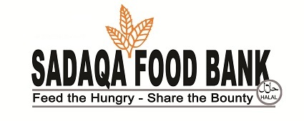
Volunteer Application Form
Thank you for your interest in volunteering to help fight community hunger alongside the Sadaqa Food Bank. Volunteers are our most valuable and an integral part in the work we do. Without the hard work and dedication of volunteers, we would not exist to serve.

Name:_____________________________________________________Date: ___________________________
Address:___________________________________________________________________________________
City:________________ Postal Code:_______________Language(s) you speak: _________________________
Phone #s (Cell):______________________(Home):_____________________(Work):_____________________
Email Address:______________________________________________________________________________
Date of Birth:___________________________Valid Driver’s License (Yes or No):_________________________
In case of emergency, please contact:
Name:____________________________________ Relationship:_____________________________________
Phone # (Home):_______________________(Work):_____________________(Cell):_____________________
Please check each of the following areas in which you are interested in assisting:
Food Sorting - (Operations Hub) – (Thursdays, Saturdays, Sundays)
Food Bundling & Handing Out (Distribution Hub) – (Saturdays, Sundays)
Food Delivery (Driver Licence and vehicle required)
Food Pick-up (Driver Licence and vehicle required)
Special Events (Fundraising, School Campaigns, Outreach programs)
Cleaning & Garbage Disposal
Others e.g. Project Development, Grants & Sponsorships, Marketing etc.___________________________

Please indicate when you are available:
Thursday: 9:30am to 1:00 pm
Saturday: 9:30am to 1:00pm
Sunday: 9:30am to 1:00pm

Special Consent:
- I understand that in the course of volunteering for the Sadaqa Food Bank, I may be dealing with confidential information and I agree to keep such information in the strictest confidence.
- I understand that I am not authorized to copy, add or delete any data/record from the Sadaqa Food Bank database/systems and equipment (computers, phones, photocopier, fax, etc.).
- I recognize that I am not authorized to speak publicly on organizational matters on behalf of the Sadaqa Food Bank.
- I understand that in the course of my volunteer work, I could be photographed or videoed by media, or SFB staff. Please identify this to SFB should you wish not to be photographed or videoed.

Signatures

Signed:_________________________________
Parent/Guardian Signature if under 18:___________________________________________________
Date:__________________________________

Are there any medical concerns we should be aware of?
__________________________________________________________________________________________
Do you require documentation for your hours?
If yes – please state reason*:_______________________________________________________________
No, I do not require documentation.

